Nepal College of Information Technology
Unit Test
Spring 2011
Program : BE CE/ELX Time : 2 hrs
Semester : (IV) FM : 70
Subject : Electronic Circuits PM : 35

- Candidates are requested to give their answer as far as practicable in their own words.
- The figure in the margin indicates the full marks
- Attempt ALL question

1 a. Darlington pair amplifier is regarded as “super – beta transistor”. Justify. 8
b. Describe the effect of shunt capacitance on high frequency response with necessary diagram. 7
2. a Find overall voltage gain (VL/Vs) in dB and show all its values in equivalent circuit of circuit below. (Assume re= 25Ω , β = 100 , rc = 10 kΩ ) 8

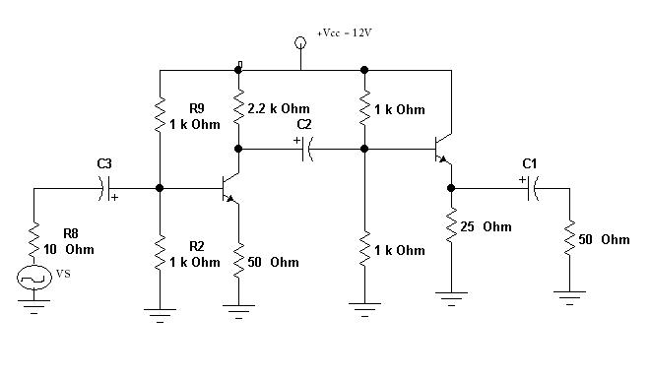
b. Describe Astable multivibrator with necessary diagram. 7
3. a. Design an operational Amplifier circuit that will produce an output equal to -10 V1 + 5V2 + 3V3 – 0.5 V4. 8
b. Derive an expression for output voltage of a basic logarithmic amplifier. List its drawbacks. 7
4. a. “Negative feedback provides gain stability and improves SNR “. Justify. 8
b. what is coupling and what are methods of coupling ? Calculate the overall gain in dB of n-stage cascaded amplifier. 3+4
5. Write short notes on: (Any Two) 5*2=10
a) Differential amplifier
b) CMRR
c) Ideal characteristics of Op-Amp
d) Frequency response.

